

Nama : Abdurrohman

Nim : 210511035

Kelas :R1(TI21A)

Kelas : R1

Overload 1

class **Math**:

    def **add**(self, a, b=None, c=None):

        if b is not None and c is not None:

            return a + b + c

        elif b is not None:

            return a + b

        else:

            return a

m = **Math**()

**print**(m.**add**(10))

**print**(m.**add**(9, 4))

**print**(m.**add**(8, 4, 10))

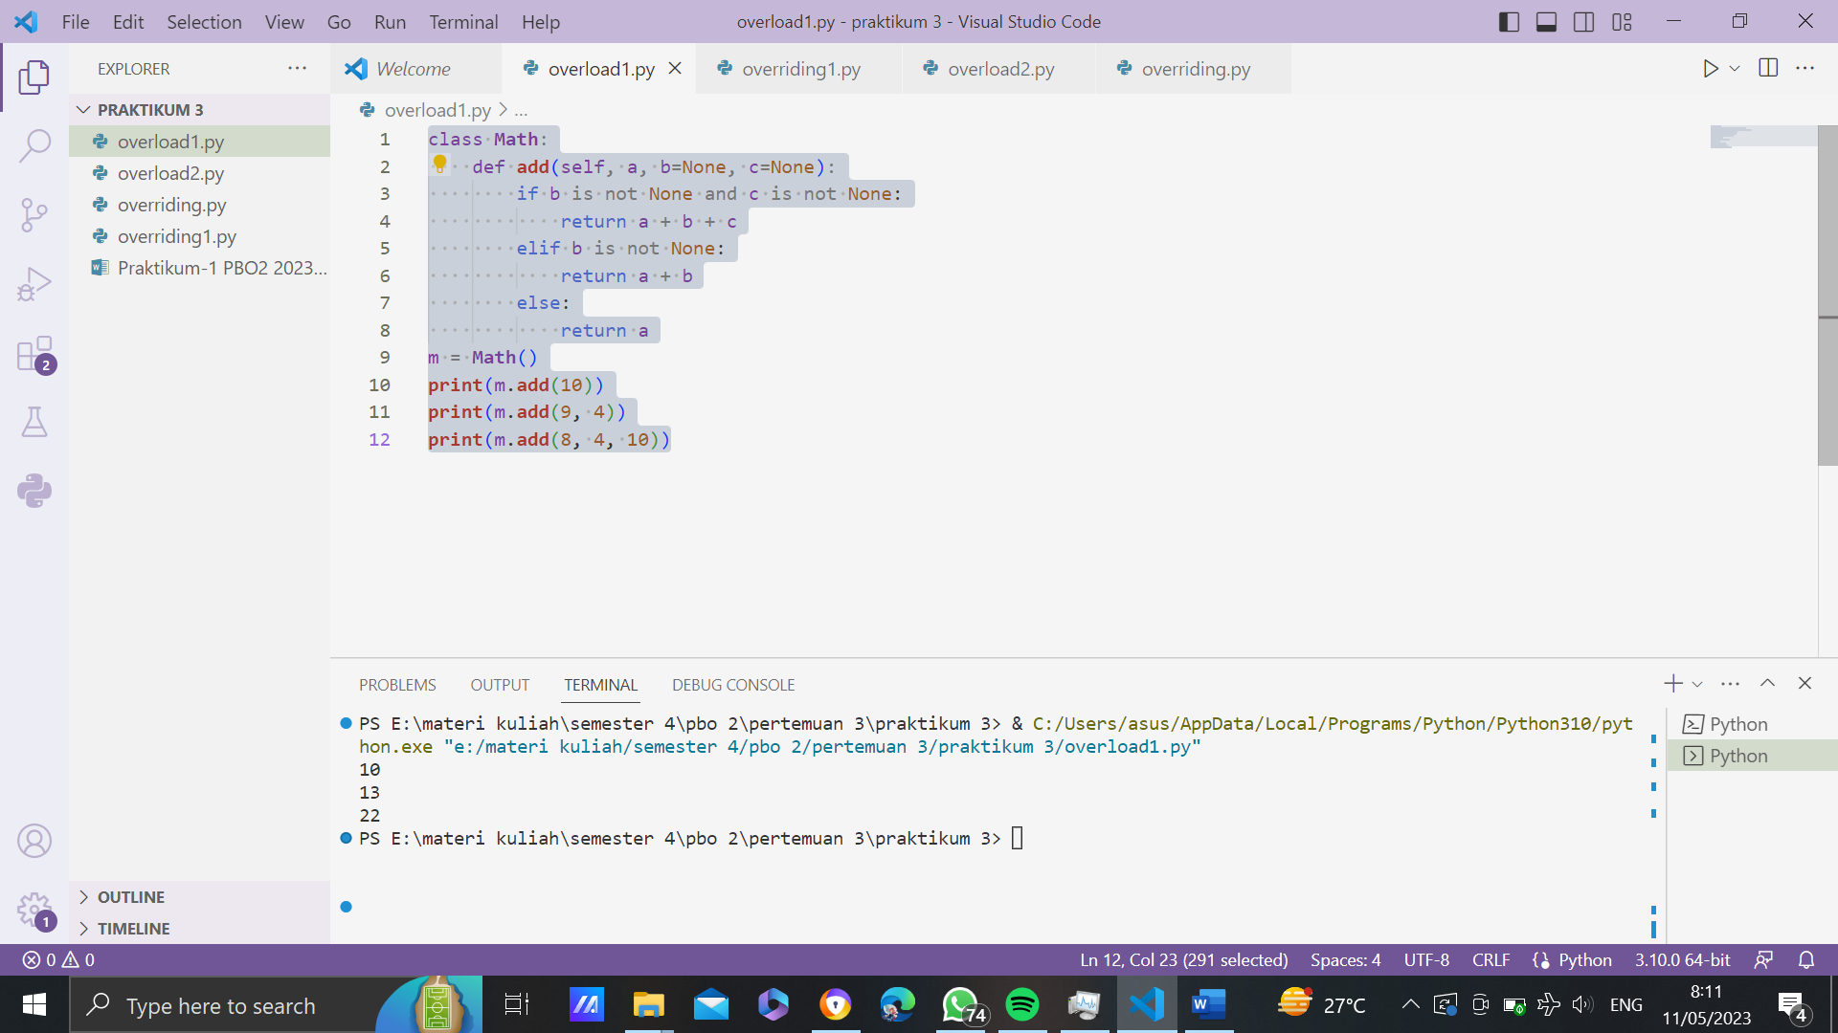

Overload 2

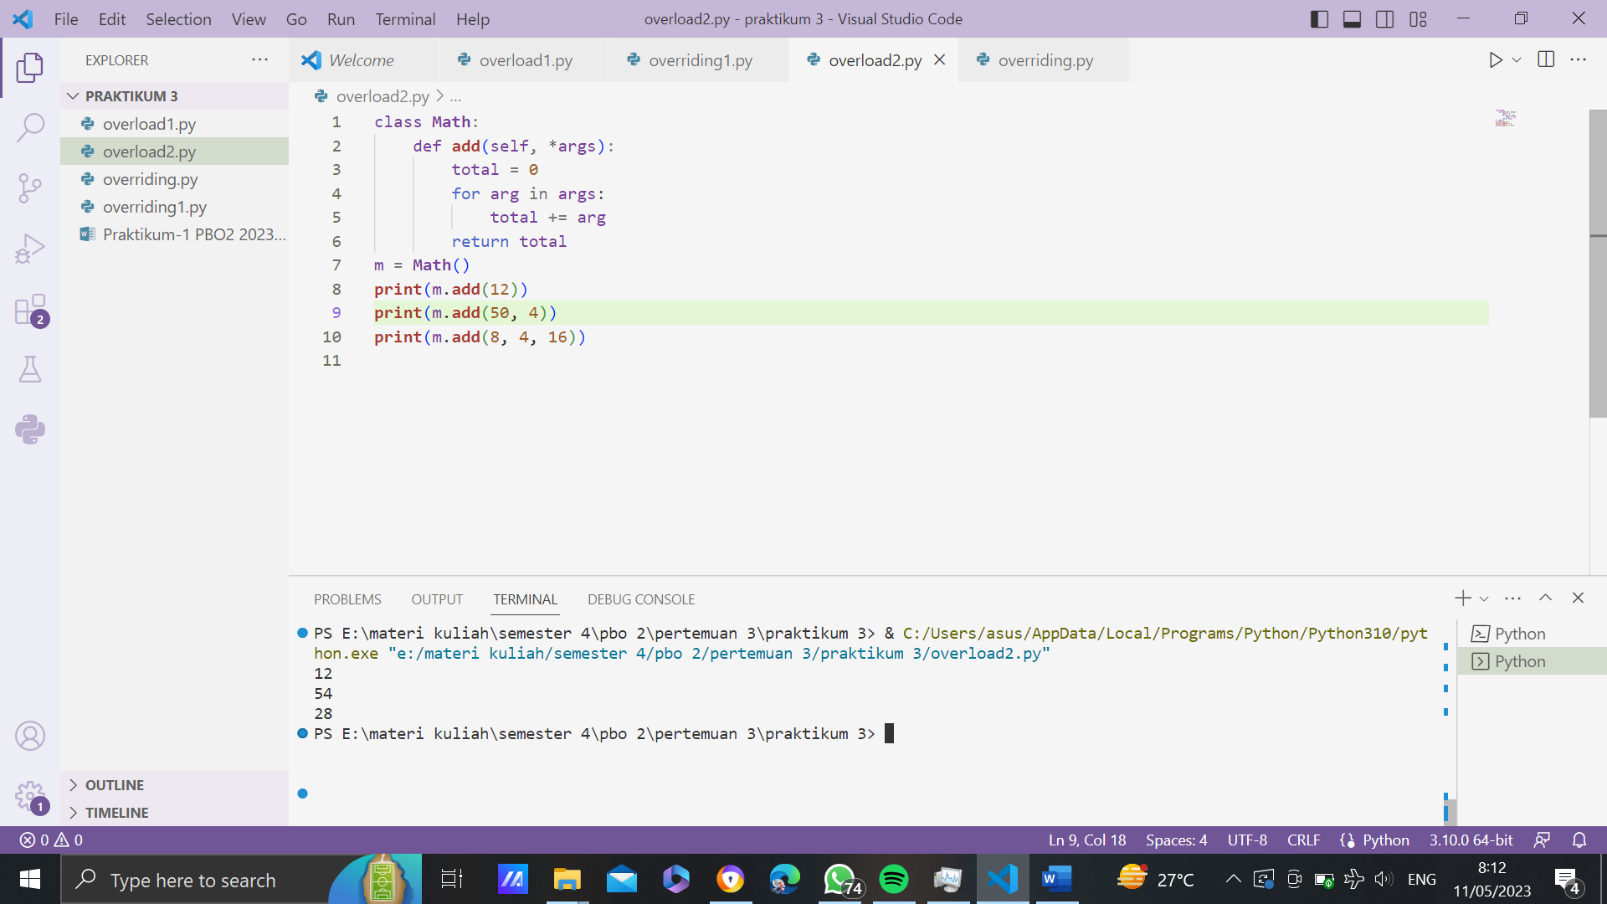

Overriding 1

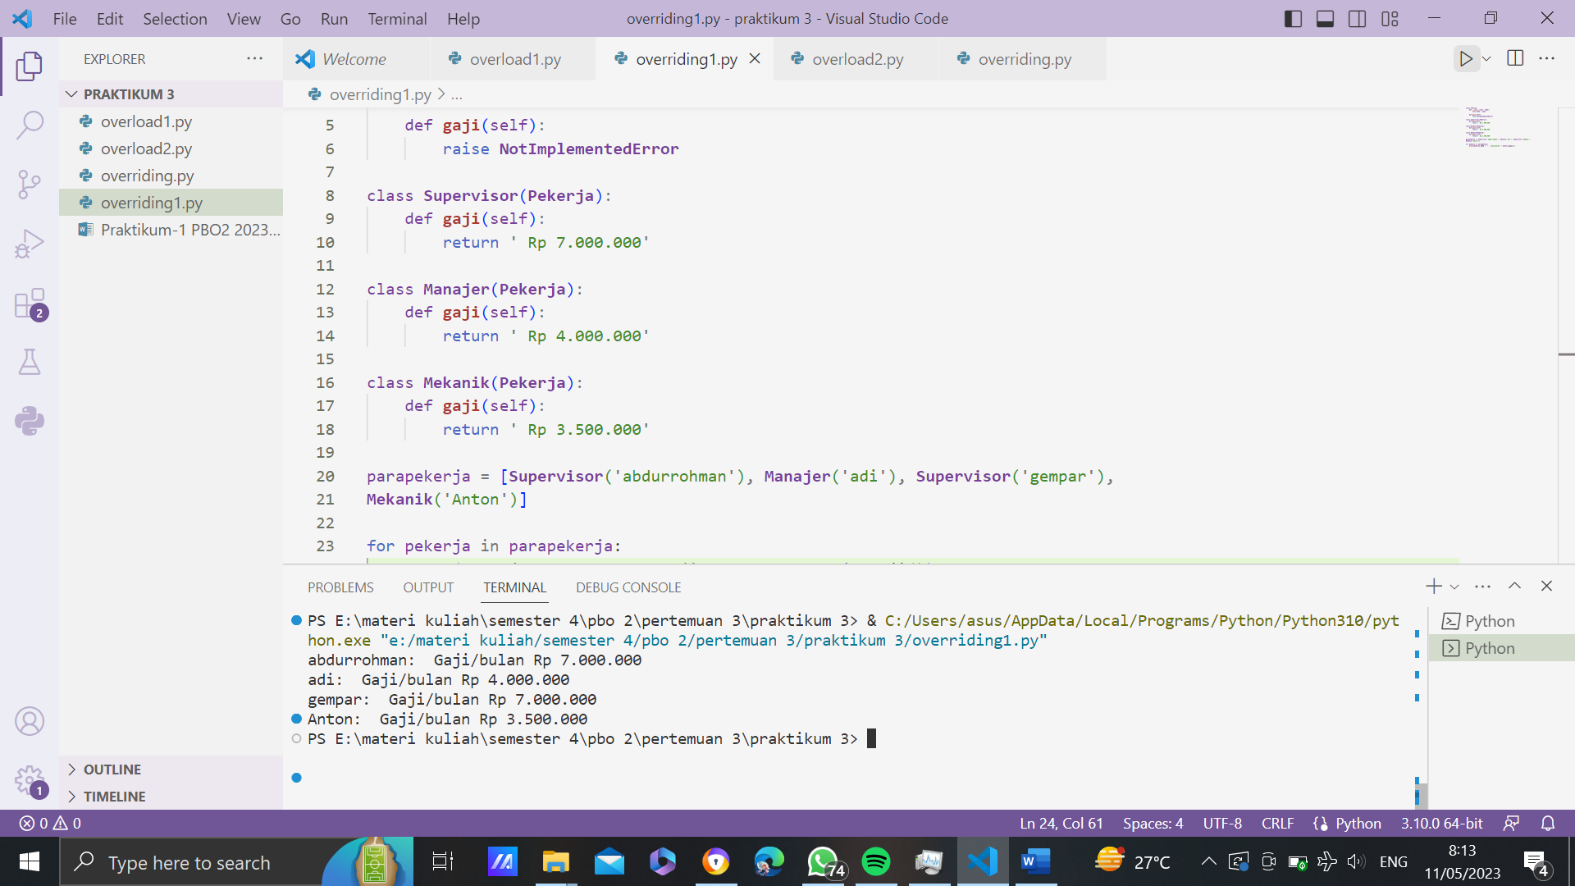

Overriding 2

